International System of Units (SI)
# Source: AI Source: Provided by: [Data Path: Persons Table -> ID Column: 1, Name_En Column: Motasem Essam] -> From: [ChatGPT] on [7/16/2026]
The International System of Units (SI) is the internationally accepted standard measurement system used worldwide for science, engineering, medicine, industry, education, and commerce. It provides a coherent, decimal-based system of units that ensures measurements are accurate, consistent, and universally understood.
The SI system was officially adopted in 1960 by the General Conference on Weights and Measures (CGPM) and is based on the earlier Metric System.

Definition
# Source: AI Source: Provided by: [Data Path: Persons Table -> ID Column: 1, Name_En Column: Motasem Essam] -> From: [ChatGPT] on [7/16/2026]
The International System of Units (SI) is the modern international standard measurement system that defines a set of base units, derived units, prefixes, and measurement rules for expressing physical quantities.
It is abbreviated as
$$\boxed{\text{SI}}$$
from the French name:
$$\boxed{\text{Syst}\overset{ˋ}{\text{e}}\text{me} \text{International} \text{d’Unit}\overset{ˊ}{\text{e}}\text{s}}$$

Purpose
# Source: AI Source: Provided by: [Data Path: Persons Table -> ID Column: 1, Name_En Column: Motasem Essam] -> From: [ChatGPT] on [7/16/2026]
The SI system is designed to:
- Standardize measurements worldwide.
- Improve scientific accuracy.
- Simplify communication.
- Facilitate international trade.
- Support engineering and manufacturing.
- Enable reproducible scientific experiments.

Characteristics
# Source: AI Source: Provided by: [Data Path: Persons Table -> ID Column: 1, Name_En Column: Motasem Essam] -> From: [ChatGPT] on [7/16/2026]
The SI system is:
- Internationally standardized.
- Decimal-based.
- Coherent.
- Scalable through prefixes.
- Based on precisely defined physical constants.
- Applicable to all branches of science and engineering.

Fundamental Principles
# Source: AI Source: Provided by: [Data Path: Persons Table -> ID Column: 1, Name_En Column: Motasem Essam] -> From: [ChatGPT] on [7/16/2026]
The SI system is based on:
- Seven base quantities.
- Seven base units.
- Derived units formed from base units.
- Decimal prefixes for multiples and submultiples.

SI Base Quantities
# Source: AI Source: Provided by: [Data Path: Persons Table -> ID Column: 1, Name_En Column: Motasem Essam] -> From: [ChatGPT] on [7/16/2026]
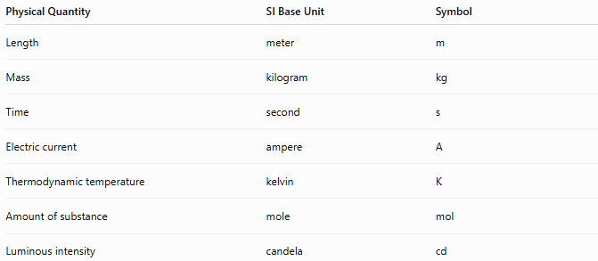
Physical Quantity | SI Base Unit | Symbol
Length | meter | m
Mass | kilogram | kg
Time | second | s
Electric current | ampere | A
Thermodynamic temperature | kelvin | K
Amount of substance | mole | mol
Luminous intensity | candela | cd

SI Base Units

1. Meter (m)
# Source: AI Source: Provided by: [Data Path: Persons Table -> ID Column: 1, Name_En Column: Motasem Essam] -> From: [ChatGPT] on [7/16/2026]
Measures:
- Length
- Distance
- Height
- Width
Example:
$$5\text{ m}$$

2. Kilogram (kg)
# Source: AI Source: Provided by: [Data Path: Persons Table -> ID Column: 1, Name_En Column: Motasem Essam] -> From: [ChatGPT] on [7/16/2026]
Measures:
- Mass
Example:
$$72\text{ kg}$$

3. Second (s)
# Source: AI Source: Provided by: [Data Path: Persons Table -> ID Column: 1, Name_En Column: Motasem Essam] -> From: [ChatGPT] on [7/16/2026]
Measures:
- Time
Example:
$$60\text{ s}$$

4. Ampere (A)
# Source: AI Source: Provided by: [Data Path: Persons Table -> ID Column: 1, Name_En Column: Motasem Essam] -> From: [ChatGPT] on [7/16/2026]
Measures:
- Electric current
Example:
$$2\text{ A}$$

5. Kelvin (K)
# Source: AI Source: Provided by: [Data Path: Persons Table -> ID Column: 1, Name_En Column: Motasem Essam] -> From: [ChatGPT] on [7/16/2026]
Measures:
- Thermodynamic temperature
Example:
$$300\text{ K}$$

6. Mole (mol)
# Source: AI Source: Provided by: [Data Path: Persons Table -> ID Column: 1, Name_En Column: Motasem Essam] -> From: [ChatGPT] on [7/16/2026]
Measures:
- Amount of substance
Example:
$$2\text{ mol}$$

7. Candela (cd)
# Source: AI Source: Provided by: [Data Path: Persons Table -> ID Column: 1, Name_En Column: Motasem Essam] -> From: [ChatGPT] on [7/16/2026]
Measures:
- Luminous intensity
Example:
$$50\text{ cd}$$

SI Derived Units
# Source: AI Source: Provided by: [Data Path: Persons Table -> ID Column: 1, Name_En Column: Motasem Essam] -> From: [ChatGPT] on [7/16/2026]
Many physical quantities are derived from combinations of base units.
Examples:
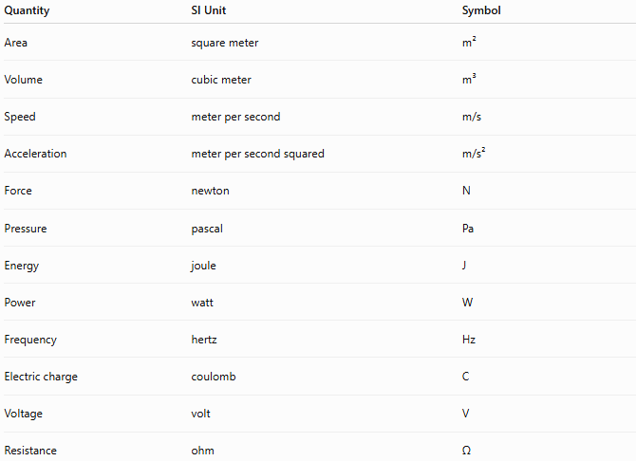
Quantity | SI Unit | Symbol
Area | square meter | m²
Volume | cubic meter | m³
Speed | meter per second | m/s
Acceleration | meter per second squared | m/s²
Force | newton | N
Pressure | pascal | Pa
Energy | joule | J
Power | watt | W
Frequency | hertz | Hz
Electric charge | coulomb | C
Voltage | volt | V
Resistance | ohm | Ω

SI Prefixes
# Source: AI Source: Provided by: [Data Path: Persons Table -> ID Column: 1, Name_En Column: Motasem Essam] -> From: [ChatGPT] on [7/16/2026]
The SI system uses prefixes to represent multiples and fractions of units.
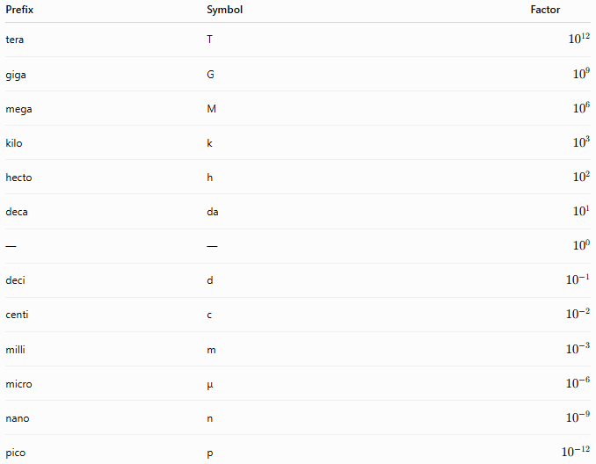
Prefix | Symbol | Factor
tera | T | $${10}^{12}$$
giga | G | $${10}^{9}$$
mega | M | $${10}^{6}$$
kilo | k | $${10}^{3}$$
hecto | h | $${10}^{2}$$
deca | da | $${10}^{1}$$
— | — | $${10}^{0}$$
deci | d | $${10}^{-1}$$
centi | c | $${10}^{-2}$$
milli | m | $${10}^{-3}$$
micro | μ | $${10}^{-6}$$
nano | n | $${10}^{-9}$$
pico | p | $${10}^{-12}$$

Examples of SI Units
# Source: AI Source: Provided by: [Data Path: Persons Table -> ID Column: 1, Name_En Column: Motasem Essam] -> From: [ChatGPT] on [7/16/2026]
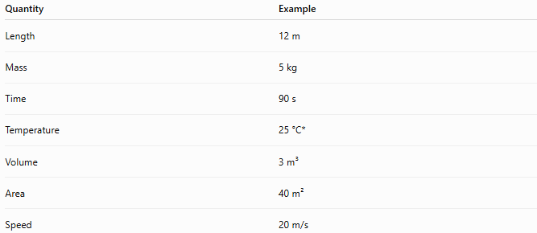
Quantity | Example
Length | 12 m
Mass | 5 kg
Time | 90 s
Temperature | 25 °C*
Volume | 3 m³
Area | 40 m²
Speed | 20 m/s
*The degree Celsius (°C) is an SI-derived unit accepted for use with SI, while the SI base unit for thermodynamic temperature is the kelvin (K).

Advantages
# Source: AI Source: Provided by: [Data Path: Persons Table -> ID Column: 1, Name_En Column: Motasem Essam] -> From: [ChatGPT] on [7/16/2026]
The SI system:
- Is internationally accepted.
- Simplifies calculations using powers of ten.
- Provides consistent measurement standards.
- Supports scientific research.
- Enables easy unit conversion.
- Reduces measurement errors.

Applications
# Source: AI Source: Provided by: [Data Path: Persons Table -> ID Column: 1, Name_En Column: Motasem Essam] -> From: [ChatGPT] on [7/16/2026]
The SI system is used in:
- Mathematics
- Physics
- Chemistry
- Biology
- Engineering
- Medicine
- Manufacturing
- Construction
- Astronomy
- Environmental science
- International trade

Everyday Examples
# Source: AI Source: Provided by: [Data Path: Persons Table -> ID Column: 1, Name_En Column: Motasem Essam] -> From: [ChatGPT] on [7/16/2026]
SI units are used when:
- Measuring room dimensions in meters.
- Buying groceries in kilograms.
- Measuring medicine in milliliters.
- Timing events in seconds.
- Recording temperatures in degrees Celsius.
- Measuring electricity in amperes and volts.

Common Mistakes
# Source: AI Source: Provided by: [Data Path: Persons Table -> ID Column: 1, Name_En Column: Motasem Essam] -> From: [ChatGPT] on [7/16/2026]
- Confusing mass (kg) with weight (N).
- Mixing SI units with Imperial units.
- Omitting unit symbols.
- Using incorrect prefixes.
- Writing unit symbols incorrectly (e.g., using Kg instead of kg).

Key Points
# Source: AI Source: Provided by: [Data Path: Persons Table -> ID Column: 1, Name_En Column: Motasem Essam] -> From: [ChatGPT] on [7/16/2026]
- SI is the world's standard measurement system.
- It is based on seven base units.
- It is decimal-based and uses powers of ten.
- Derived units are formed from base units.
- SI is the preferred system for science, engineering, and international commerce.

SI System vs. Metric System
# Source: AI Source: Provided by: [Data Path: Persons Table -> ID Column: 1, Name_En Column: Motasem Essam] -> From: [ChatGPT] on [7/16/2026]
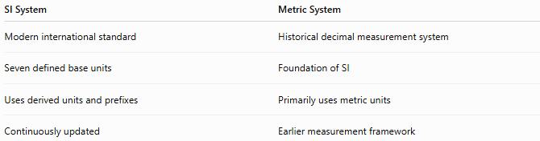
SI System | Metric System
Modern international standard | Historical decimal measurement system
Seven defined base units | Foundation of SI
Uses derived units and prefixes | Primarily uses metric units
Continuously updated | Earlier measurement framework

SI System vs. Imperial System
# Source: AI Source: Provided by: [Data Path: Persons Table -> ID Column: 1, Name_En Column: Motasem Essam] -> From: [ChatGPT] on [7/16/2026]
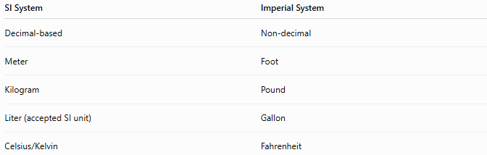
SI System | Imperial System
Decimal-based | Non-decimal
Meter | Foot
Kilogram | Pound
Liter (accepted SI unit) | Gallon
Celsius/Kelvin | Fahrenheit

SI System vs. US Customary System
# Source: AI Source: Provided by: [Data Path: Persons Table -> ID Column: 1, Name_En Column: Motasem Essam] -> From: [ChatGPT] on [7/16/2026]
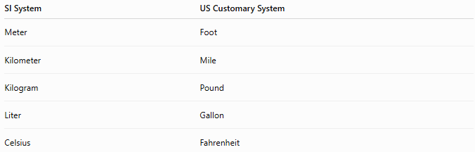
SI System | US Customary System
Meter | Foot
Kilometer | Mile
Kilogram | Pound
Liter | Gallon
Celsius | Fahrenheit

Conclusion
# Source: AI Source: Provided by: [Data Path: Persons Table -> ID Column: 1, Name_En Column: Motasem Essam] -> From: [ChatGPT] on [7/16/2026]
The International System of Units (SI) is the globally recognized standard measurement system used to express physical quantities accurately and consistently. Based on seven base units, it provides a coherent, decimal-based framework for defining both fundamental and derived units. Its universal adoption has made it indispensable in science, engineering, medicine, education, industry, and international commerce, ensuring that measurements are reliable, comparable, and understood worldwide.

